**LAB 6 TASK**

**Q1) What is the current version of Virtual Box?**

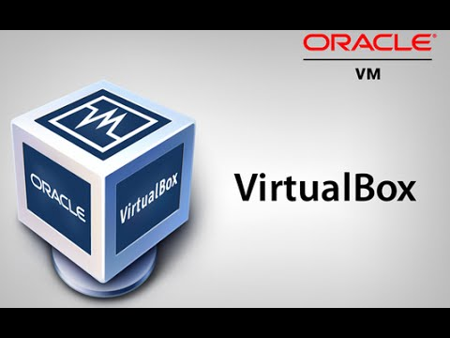

**The Virtual Box latest release is version** released on September 14th 2017.

The **version 5.1.28.**

**Requirements For Virtual Box**

## CPU and RAM

Virtual Box runs on Intel and AMD processors even if they don't support their manufacturers' VT-x or AMD-V virtualization technologies.

## Storage

Oracle doesn't specify a storage requirement for Virtual Box because the program itself is relatively small.

## Windows Requirements

Virtual Box can run on many flavors of Windows. It supports 32- and 64-bit versions of Vista, Windows 7 and Windows 8, as well as 32-bit versions of Windows XP.

**Q2) What is the current version of Fedora Linux?**



Fedora 26 was released on July 11, 2017

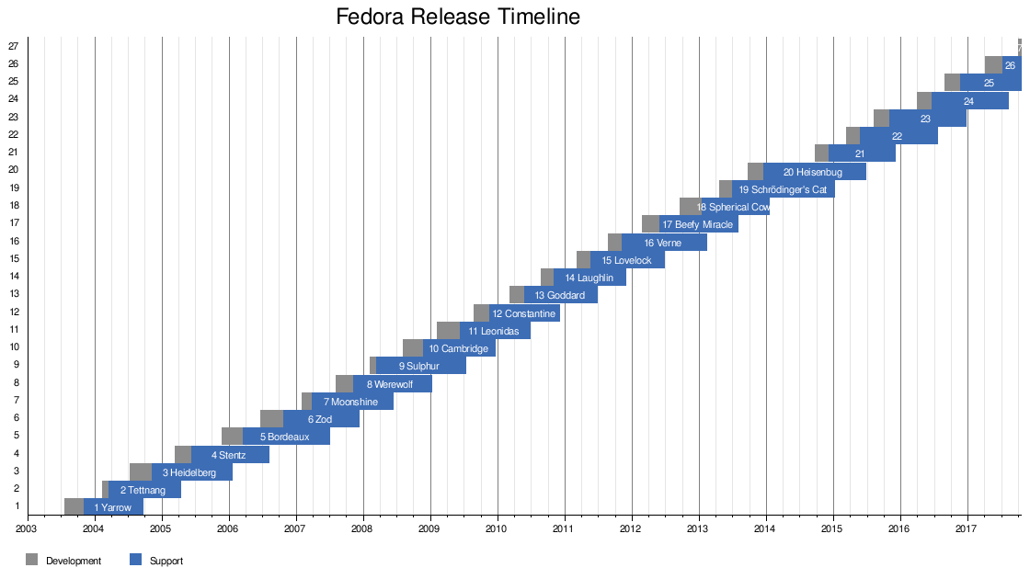

**Q3) What is the difference between a dynamically allocated hard disk and a fixed size Hard disk for virtual machines?**

#### Dynamically expanding disks

A dynamically expanding virtual hard disk is one in which the size of the .vhd file grows as data is written to the virtual hard disk. This is the default type of virtual hard disk created by Virtual Server.

When you create a dynamically expanding virtual hard disk, you specify a maximum file size. This size restricts how large the disk can become. However, the initial size of the .vhd file is only about 3 MB. For example, if you create a 1-GB, dynamically expanding virtual hard disk, the initial size of the .vhd file will be about 3 MB. As a virtual machine uses the virtual hard disk, the size of the .vhd file grows to accommodate the new data. The size of any dynamically expanding disk only grows; it does not shrink, even when you delete data. You may be able to reduce the size of a dynamically expanding disk by compacting it. For more information, see [Compacting dynamically expanding virtual hard disks](https://technet.microsoft.com/en-us/library/cc708394(v=ws.10).aspx).

The major benefit of this type is that the dynamic disk takes up only slightly more space that the data contained within. Roughly speaking:

* a virtual hard disk that has a maximum size of 200 GB
* and contains 10 GB of files
* is just over 10 GB in size
* that means the business saved nearly 190 GB of physical storage space

### Fixed Virtual Hard Disks

When you create a fixed-size virtual hard disk, space is reserved beforehand. Suppose you created a VHDX of 200 GB, then 200GB space will be reserved for you on the hard disk of the host. You may be using 5 or 50 GB out of it, so rest of the space is wasted and this is the real drawback of this virtual hard disk type.

Fixed virtual hard disks do not have dynamic growth, so they are not as prone to fragmentation as dynamic virtual hard disks. However, it can still happen if you manually expand a fixed virtual hard disk, or the virtual hard disk is created in a pretty full volume. Fixed virtual hard disks perform nearly at the same speed as the physical LUN that is storing them. This counters the argument for using pass-through disks for performance.

The file of a fixed virtual hard disk is created at the maximum size of the volume. Using the same example as before:

* a virtual hard disk that has a maximum size of 200 GB
* and contains 10 GB of files
* is just over 200 GB in size
* that means the business nearly 190 GB of overused physical storage space